**Explanation: Q5 - Encapsulation in Java**

**What is Encapsulation?**  
Encapsulation is an object-oriented programming principle where the internal details of a class (data members) are hidden from the outside world and access is only provided through public methods.  
This helps in protecting the integrity of the object by preventing unintended or harmful modifications.

### How to Achieve Encapsulation in Java:

1. Declare class variables as private to restrict direct access.
2. Provide public **getter** and **setter** methods to access and modify the values safely.

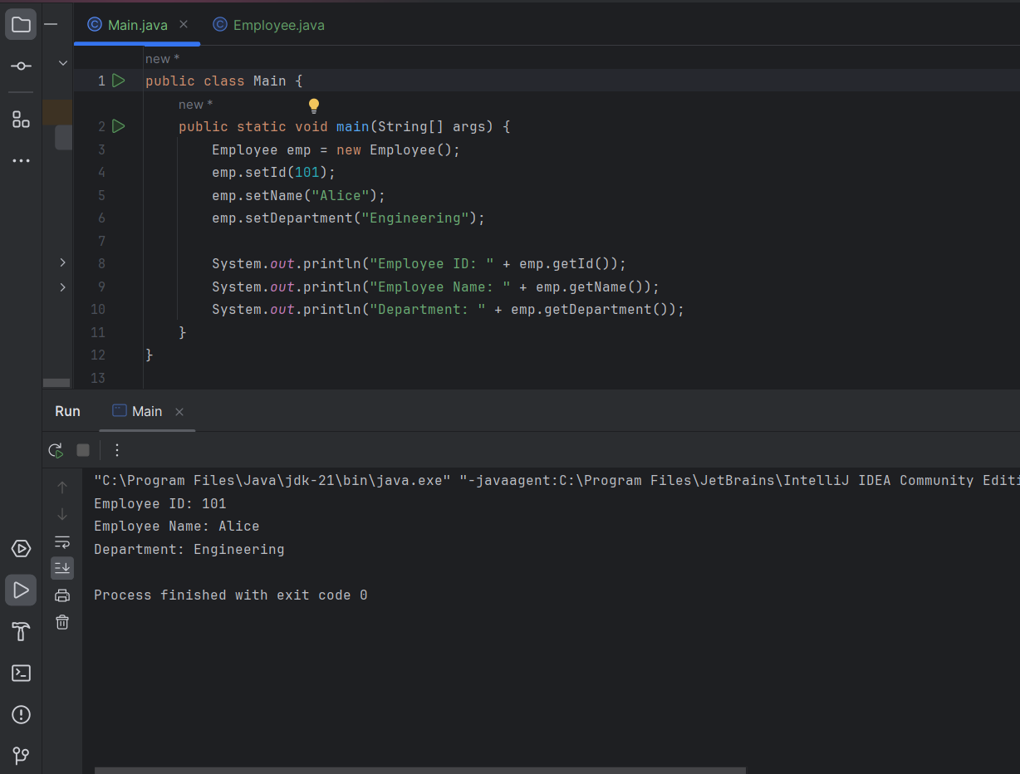

**Key Takeaway:**  
By keeping class variables private and providing controlled access through getters and setters, encapsulation helps in data hiding and enforces modular and secure code design.